January 17, 2022
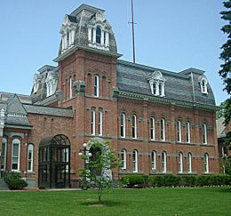
Delaware County Court Employee
Tests Positive for Coronavirus

Contact: NYS OCA Coronavirus Hotline at 1-833-503-0447

(Delhi, NY – January 17, 2022) – The Court was informed today, Monday, January 17, 2022, that a Delaware County Court Employee has tested positive for the Coronavirus. The individual was last in the Delaware County Courthouse, located at 3 Court Street, Delhi, NY 13753, on Friday, January 14, 2022.

The Courthouse will take the necessary precautions to clean and disinfect.

For more information about COVID-19, go to the websites for the Delaware County Department of Health and NYS Department of Health. Anyone who exhibits Covid-19 symptoms including, but not limited to, fever, shortness of breath, loss of taste or smell and coughing should contact a health care provider.

