January 17, 2022

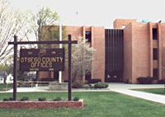

Second Otsego County Court Employee
Tests Positive for Coronavirus

Contact: NYS OCA Coronavirus Hotline at 1-833-503-0447

(Cooperstown, NY – January 17, 2022) – The court was informed today, Monday, January 17, 2022, that a Second Otsego County Court employee has tested positive for the Coronavirus. The individual was last in the County Office Building, located at 197 Main Street, Cooperstown, NY 13326, on Friday, January 14, 2022.

The courthouse will take precautions and be cleaned and disinfected.

For more information about COVID-19, go to the Otsego County Department of Health and NYS Department of Health. Anyone who has symptoms including fever, shortness of breath, and cough should contact a health care provider.

