January 6, 2022
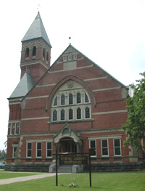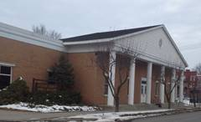

Second Otsego County Court Employee
Tests Positive for Coronavirus

Contact: NYS OCA Coronavirus Hotline at 1-833-503-0447

(Cooperstown, NY – January 6, 2022) – The court was informed last night, Wednesday, January 5, 2022, that a second Otsego County Court employee has tested positive for the Coronavirus. The individual was last in the courthouse, located at 193 Main Street, Cooperstown, NY 13326, and the County Annex Building, located at 32 Chestnut Street, Cooperstown, NY 13326, on Monday, January 3, 2022.

A contact investigation is underway and is being conducted by the Otsego County Health Department nurses to identify close contacts and potential exposures. The Health Department will notify anyone who may have been exposed and will advise them as to what steps they need to take.

The courthouse will take precautions and be cleaned and disinfected.

For more information about COVID-19, go to the Otsego County Department of Health and NYS Department of Health. Anyone who has symptoms including fever, shortness of breath, and cough should contact a health care provider.

