January 11, 2022
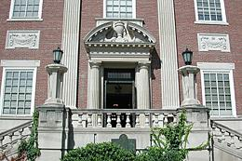
Tompkins County Court Employee
Tests Positive for Coronavirus

Contact: NYS OCA Coronavirus Hotline at 1-833-503-0447

(Ithaca, NY – January 11, 2022) – The court was informed today, Tuesday, January 11, 2022 that a Tompkins County Court Employee has tested positive for the Coronavirus. The individual was last in the Tompkins County Courthouse, located at 320 N. Tioga Street, Ithaca, NY 14850, on Monday, January 10, 2022.

The courthouse will take the necessary precautions to clean and disinfect.

For more information about COVID-19, go to the websites for the Tompkins County Department of Health and NYS Department of Health. Anyone who exhibits Covid-19 symptoms including, but not limited to, fever, shortness of breath, loss of taste or smell and coughing should contact a health care provider.

